
Neuroscience at Oxford Science and Ideas Festival
11-22 October 2018
Keen to engage the public with your brain-related research? Got the basis of an idea but not sure how to make it work? This could be an exciting opportunity for you.
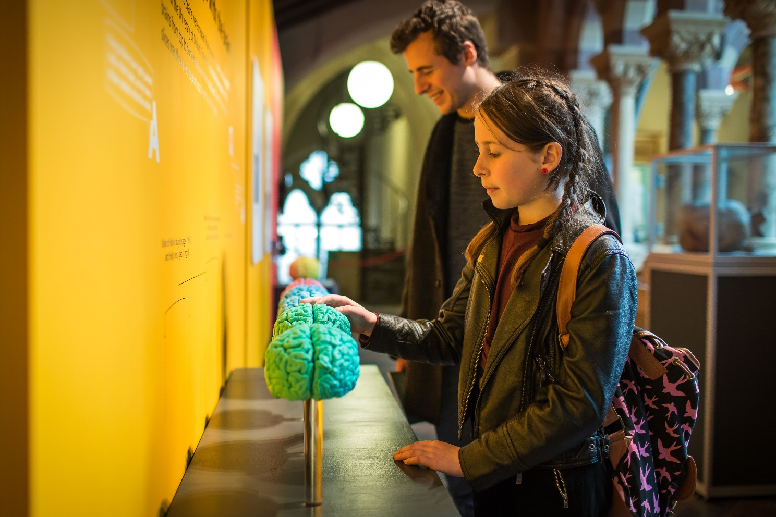
IF Oxford (formerly the Oxfordshire Science Festival) has already issued a call for expressions of interest (deadline Monday 30 April) for the Festival, 12-22 October 2018, with various locations around Oxford.
Oxford Neuroscience will be submitting a coordinated application for a themed programme strand (deadline Wednesday 4 April.) This is so that we can give our audience the best sense of the huge variety of neuroscience research and its impacts from the University of Oxford. We strongly encourage you to submit your ideas through this internal call, so that you can benefit from the support on offer.
Items within the neuroscience strand could include talks and debates, performances and exhibitions throughout the Festival (which will include two busy weekends of hands-on activities, performances and workshops in Oxford city centre and south-east Oxford). The Festival team can help develop your ideas and will manage ticketing, event recording and evaluation.
There is a flexible funding model for applications submitted through Oxford Neuroscience, with details to be arranged once the Oxford Neuroscience application has been submitted – so don’t worry if at this stage you don’t have access to funding.
There will be a facilitation event including tea and cakes on Tuesday 10 April from 2.00-5.00pm in Seminar Room 4B, George Pickering Education Centre, Level 3, JR Hospital. This will be run by Dane Comerford from IF Oxford, Naomi Gibson from the Medical Sciences Division, and the relevant Public Engagement lead from each participating department. The aim of this session will be to hear everyone’s ideas and synthesise them into a coherent series of events/activities.
Subsequent to this session, there will be a hands-on training session for anyone who would like more guidance on delivering the activities.
If you are interested in getting involved, please complete the following and email it to neuroscience@medsci.ox.ac.uk by 5.00pm on Wednesday 4 April.
Name
Position
Department
Phone number
Email address
Outline your area of research (150 words)
Please use language that is easy to understand. Part of this may be used as content within the brochure as a short ‘thought piece’ essay.
Outline your idea for an event/activity (150 words)
This could be a hands-on exhibit, talk, performance, workshop or debate. Why will it be interesting? How will you bring it to life? Who are the intended audience?

If you have any questions please contact the Festival Team:

Dane Comerford, Director
dane.comerford@oxscifest.org
01865 810 027
Cathy Rose, Events Manager
cathy.rose@oxscifest.org
01865 810 016

