ECR Illustration awards 2021

Dear ARUK Thames Valley network members ECRs,

We are pleased to announce our ECR Illustration awards 2021, which are aimed at facilitating science communication and publicising your research project in a visual way. These Awards are designed to provide ARUK Thames Valley network members with the opportunity to work with a professional illustration artist in order to create an image that captures your research. This image will allow you to engage with a wider audience whether through using it in presentations, posters, social media or as a great visual image at outreach events.
The chosen winners will spend approximately an hour liaising with the artist in order to get their science appropriately illustrated using a similar design template show below:-

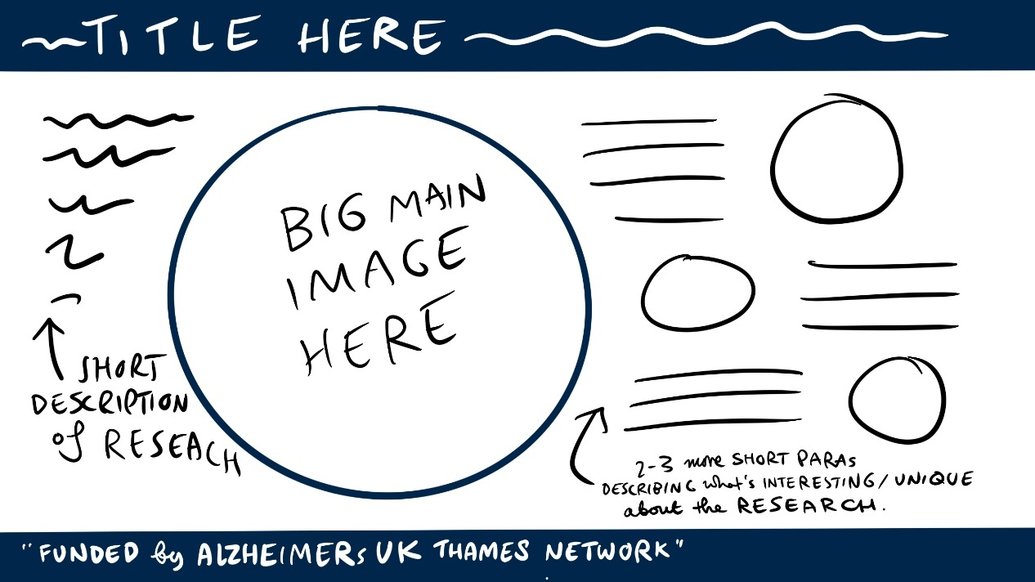

Once the artwork is completed, you will receive a digital version of the illustration to allow you to use the artwork as you wish. We are encouraging network members from any scientific background to apply. The Awards will be allocated based on the following criteria:

- A short scientific summary of your research project (max 400 words).
- A short summary of your research project in laymen terms (max 400 words).
- A brief outline of how your research could be illustrated using the template above (max 200 words).

Please complete the form below and return to the ARUK Thames Valley Network Administrator at aruk.administrator@dpag.ox.ac.uk by 4th June 2021.
We will evaluate proposals and hope to announce the Awards no later than 30th June 2021.

ECR Illustration awards 2021

The application proforma to access all Network Centre funding schemes
You must be a network member to apply.

Date
Name

Institution

Career Status (e.g. Year 1 PhD)

Email

Application Details

Please note that successful award recipients will be asked to use social media to promote how the ARUK funding has supported their career and provide a report at the end of the year.

A short scientific summary of your research project (max 400 words).

A short summary of your research project in laymen terms (max 400 words).

A written outline of an idea of how your research can be illustrated in a sketch (200 words).

Please complete the form and return to the ARUK Thames Valley Network Administrator at aruk.administrator@dpag.ox.ac.uk The deadline for completion is 4th June 2021.

